**Lesson 9 Demo 3**

**Understanding Cluster and Node Logs**



# Steps to be followed:

1. Sidecar Container demo

**Step 1: Sidecar Container demo**

1. Copy the following code into a file called **logger-sidecar.yaml**, in the master system:

***apiVersion: v1***

***kind: Pod***

***metadata:***

***name: counter-one***

***spec:***

***containers:***

***- name: count***

***image: busybox***

***args:***

***- /bin/sh***

***- -c***

***- >***

***i=0;***

***while true;***

***do***

***echo "$i: $(date)" >> /var/log/1.log;***

***echo "$(date) INFO $i" >> /var/log/2.log;***

***i=$((i+1));***

***sleep 10;***

***done***

***volumeMounts:***

***- name: varlog***

***mountPath: /var/log***

***- name: count-agent***

***image: k8s.gcr.io/fluentd-gcp:1.30***

***env:***

***- name: FLUENTD_ARGS***

***value: -c /etc/fluentd-config/fluentd.conf***

***volumeMounts:***

***- name: varlog***

***mountPath: /var/log***

***- name: config-volume***

***mountPath: /etc/fluentd-config***

***volumes:***

***- name: varlog***

***emptyDir: {}***

***- name: config-volume***

***configMap:***

***name: fluentd-config***

| **Note:** This pod uses a busybox image, and a script will run inside a while loop. This code will run continuously, as long as the pod is running, and after every 10 seconds, it will write the logs in files using the fluentd sidecar container. |
| --- |

1. Deploy the logger-sidecar.yaml into the system, as follows:

**kubectl apply -f logger-sidecar.yaml**

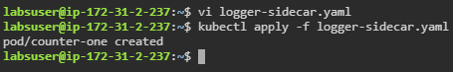

1. Now, to see the sidecar logging, provide the following command:

**kubectl logs counter-one count-log-1** or **kubectl logs counter-one count-log-2**.

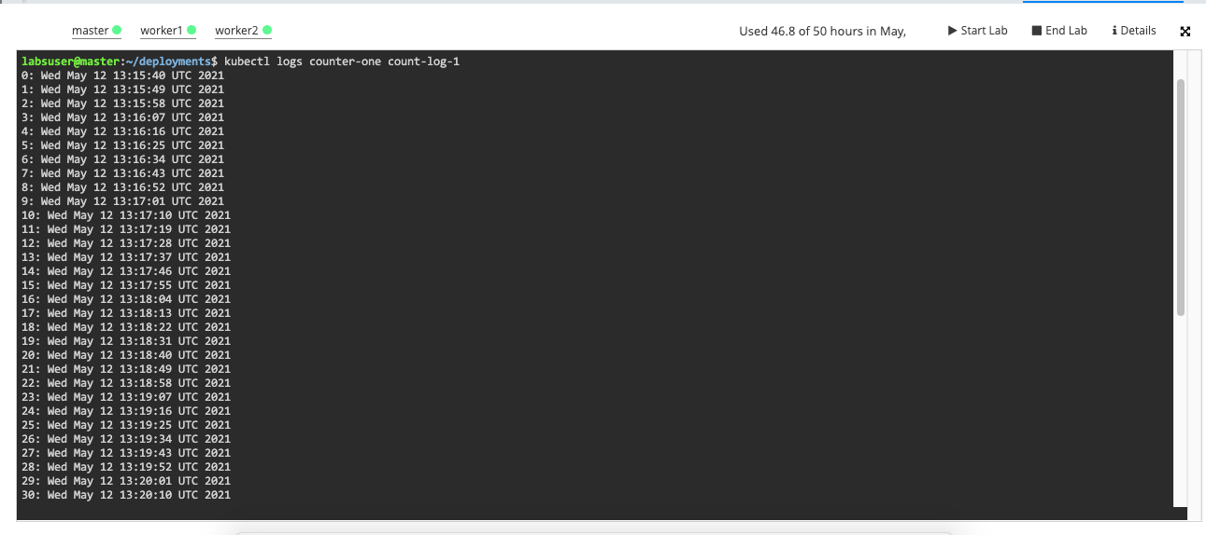

The above is for count-log-1. The below screenshot shows the log of count-log-2:

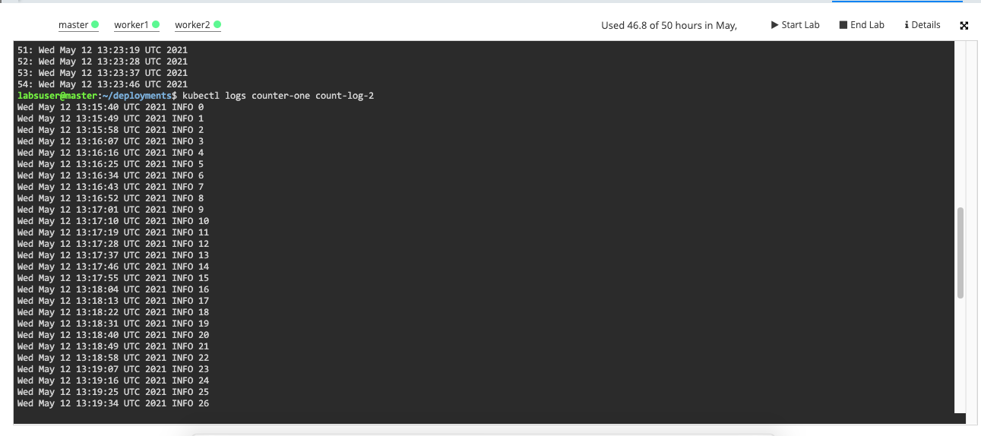

| **Note:** Please note that each logging takes 10 seconds, as shown in the two screenshots above. |
| --- |